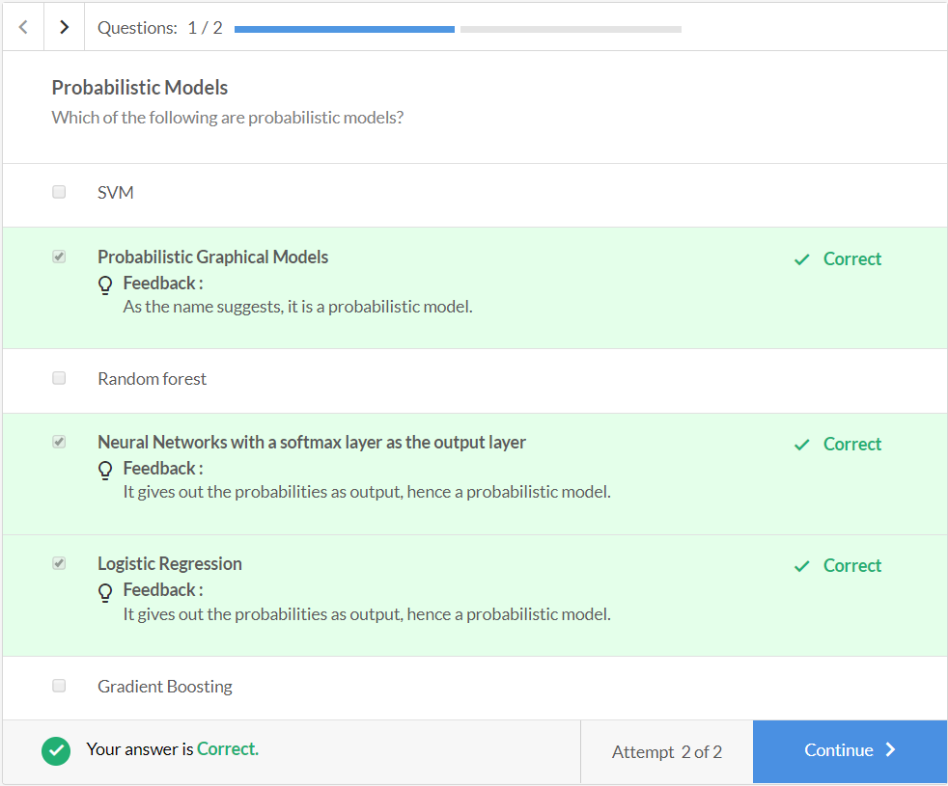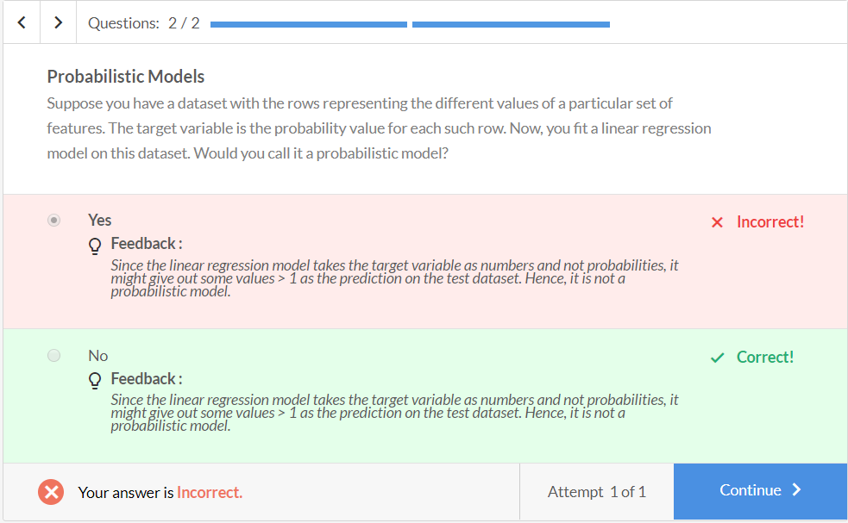

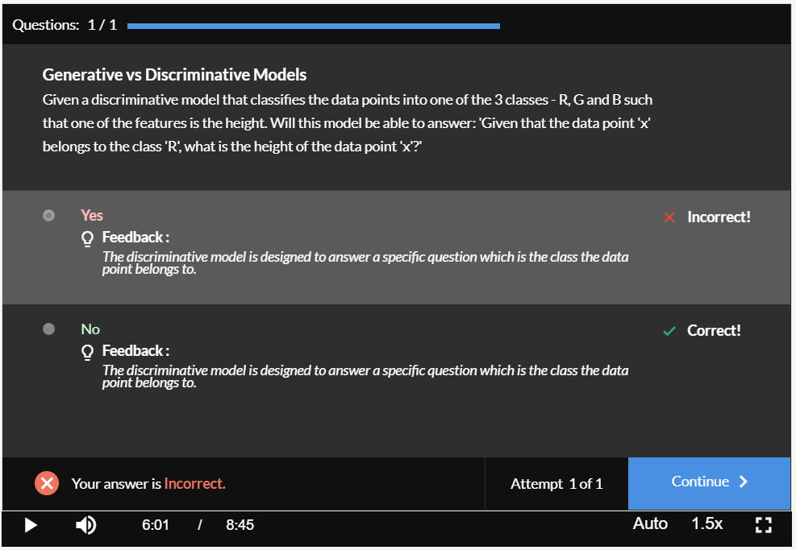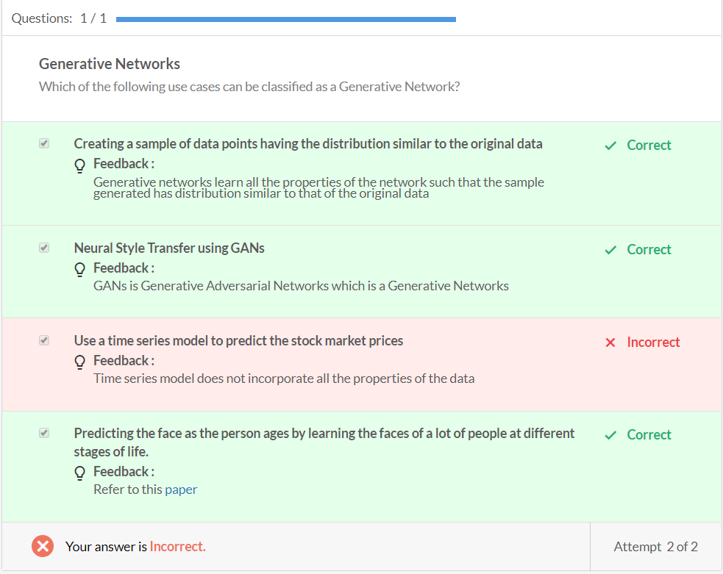

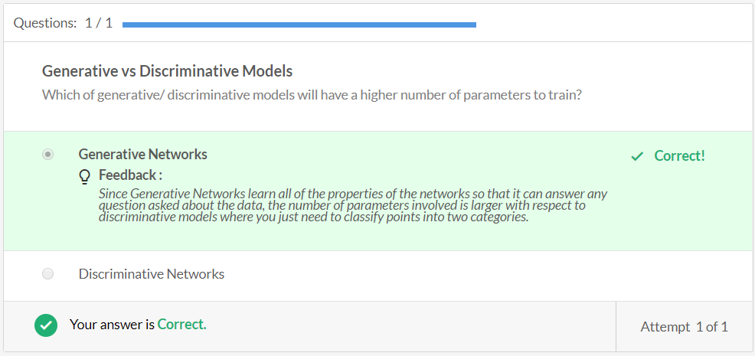

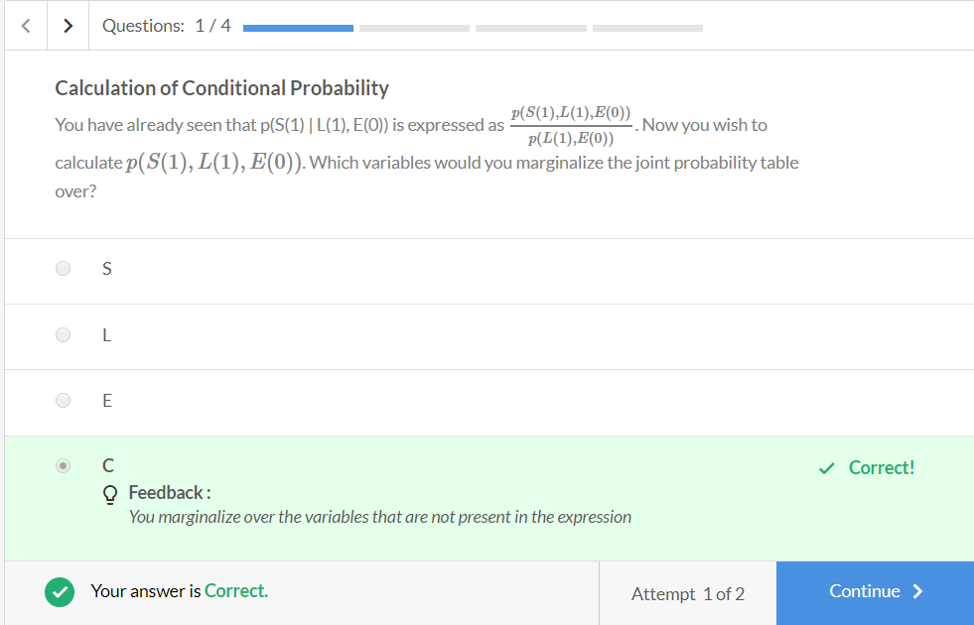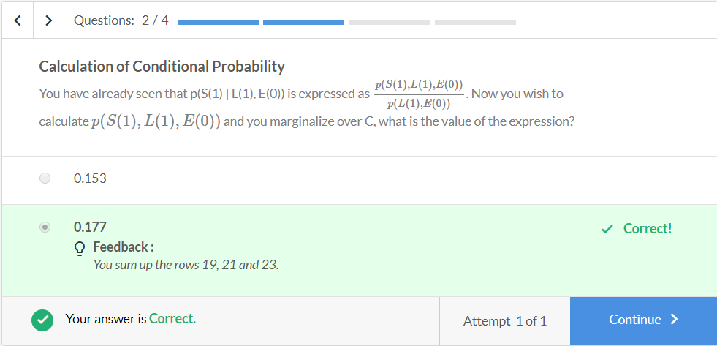

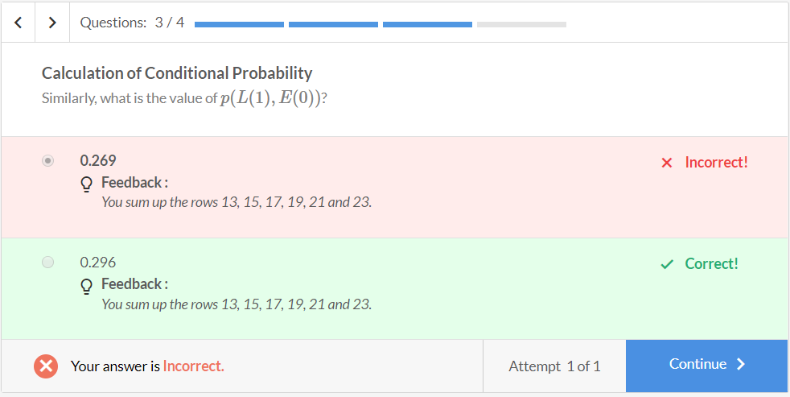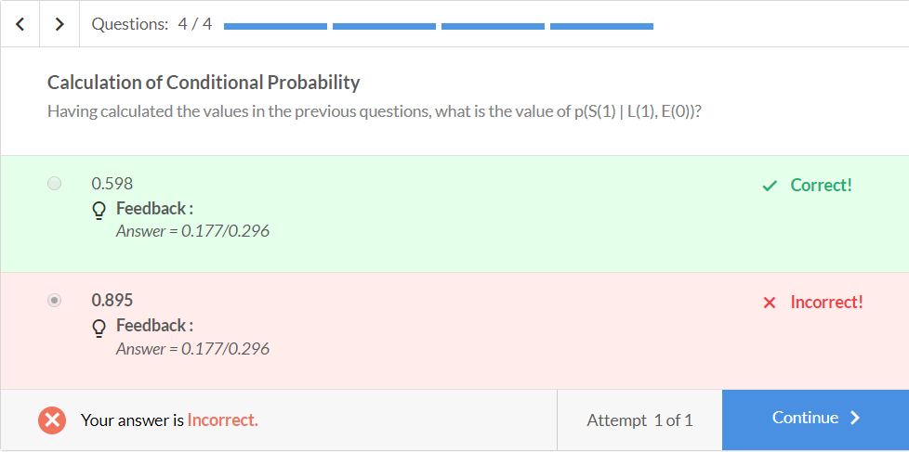

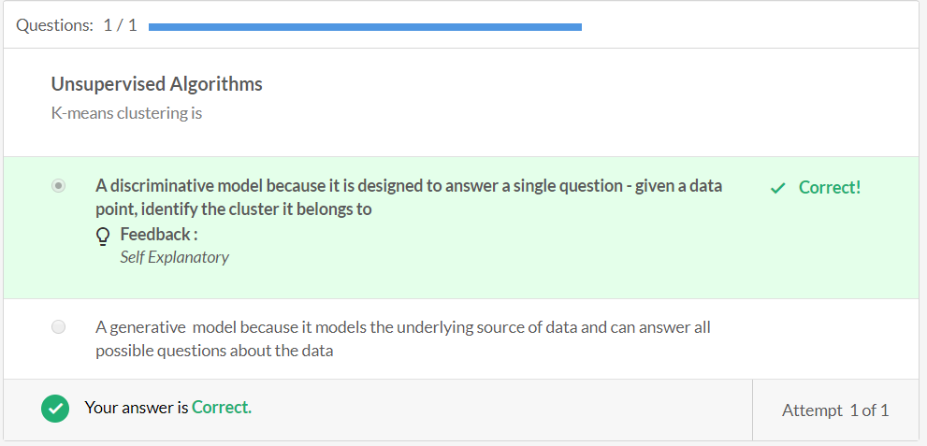 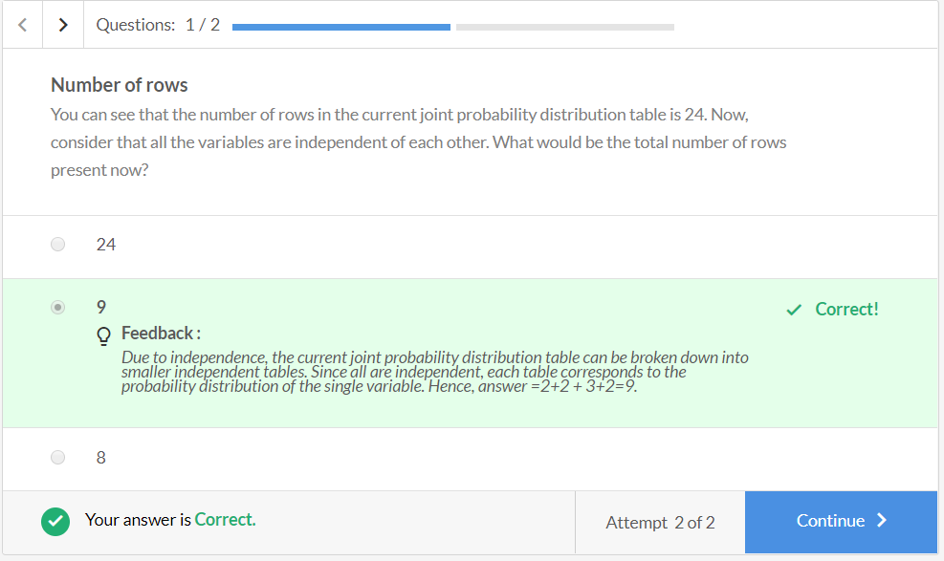

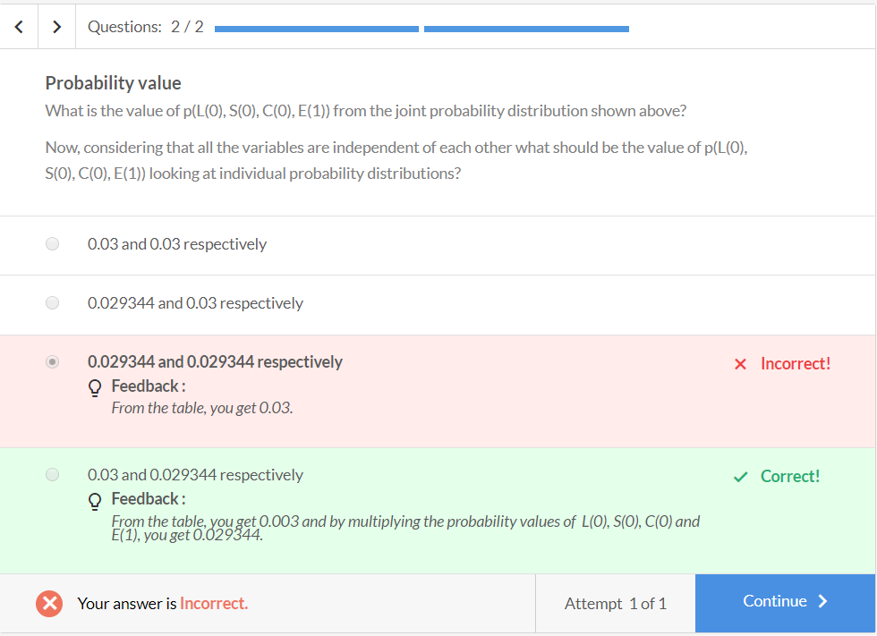 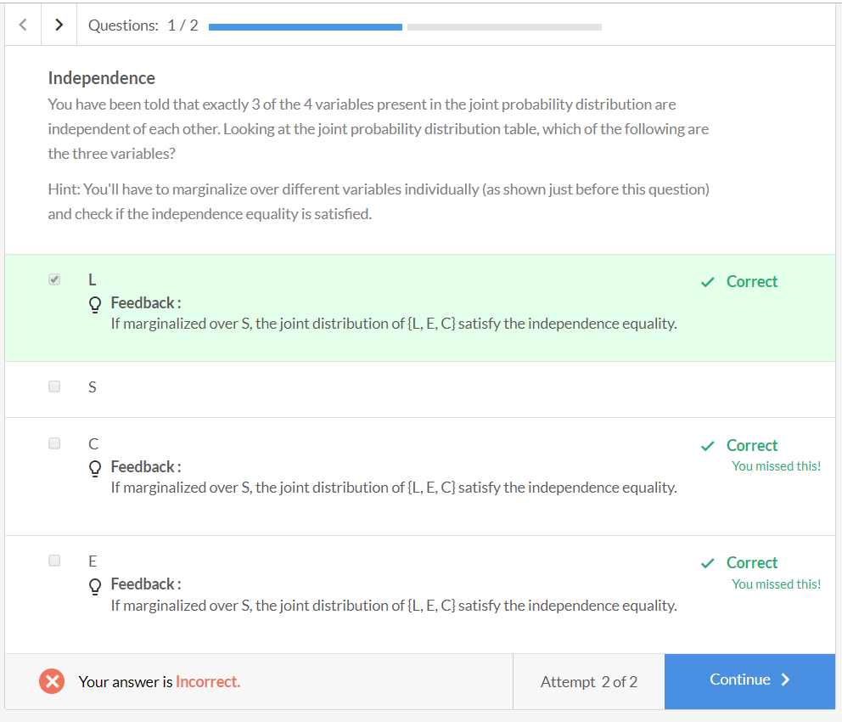

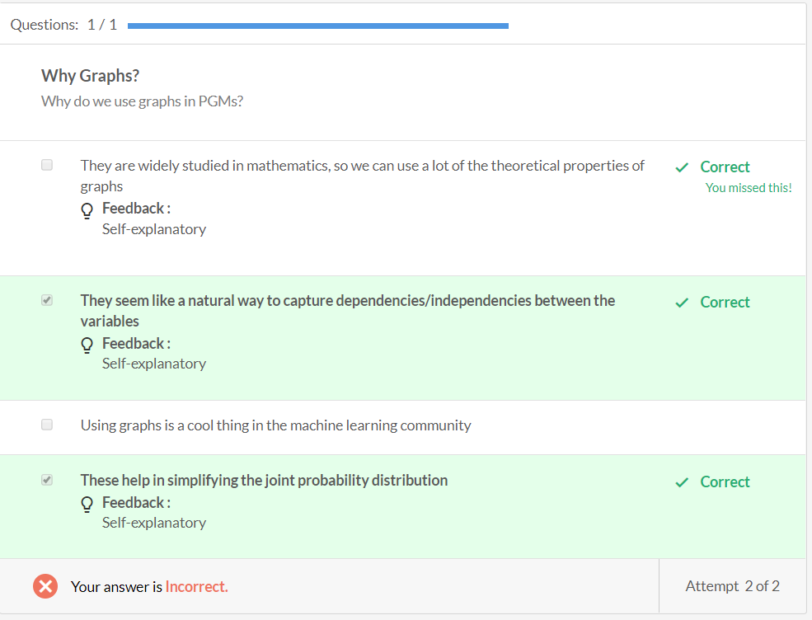 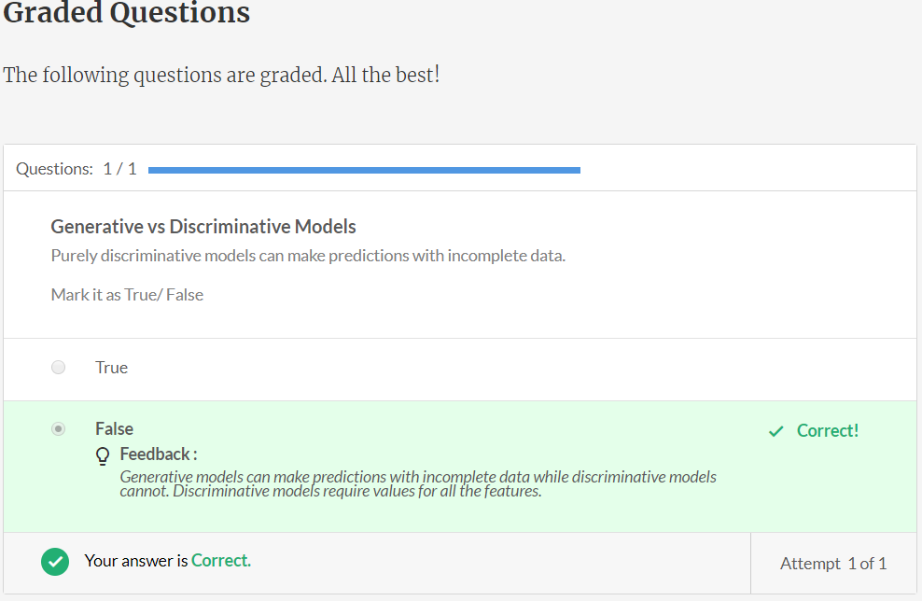

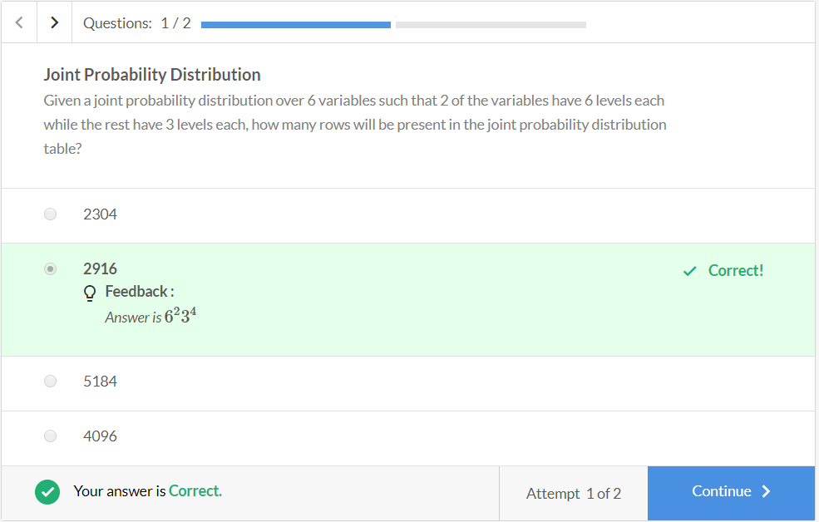 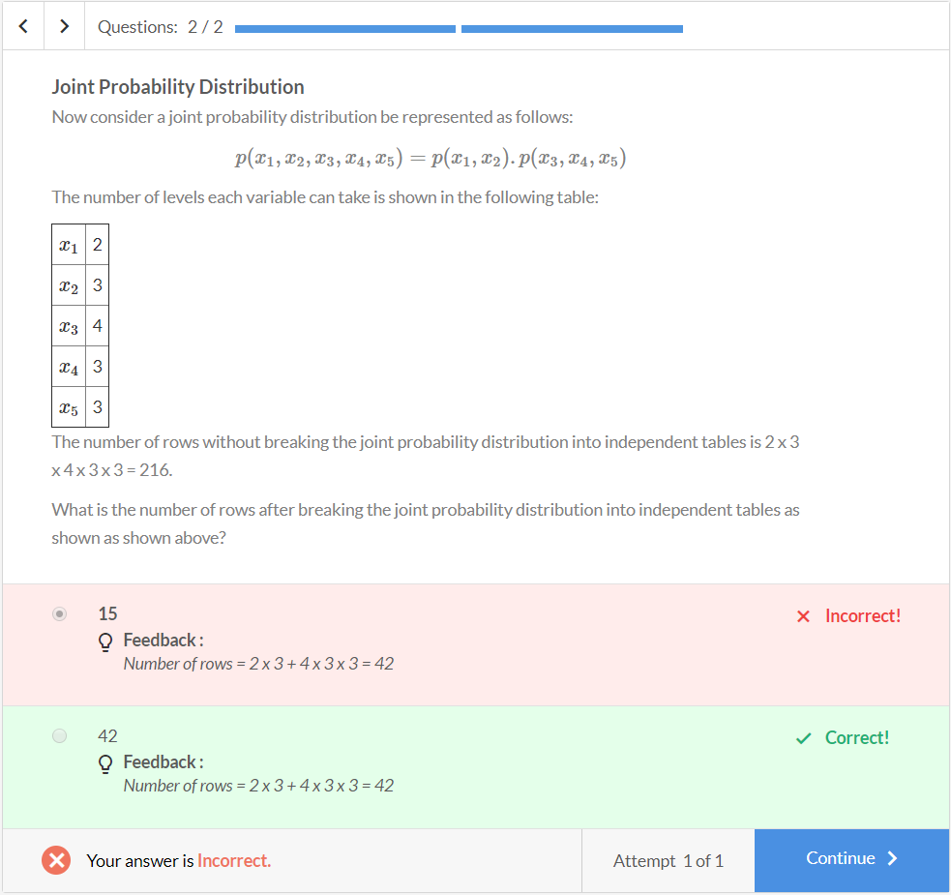

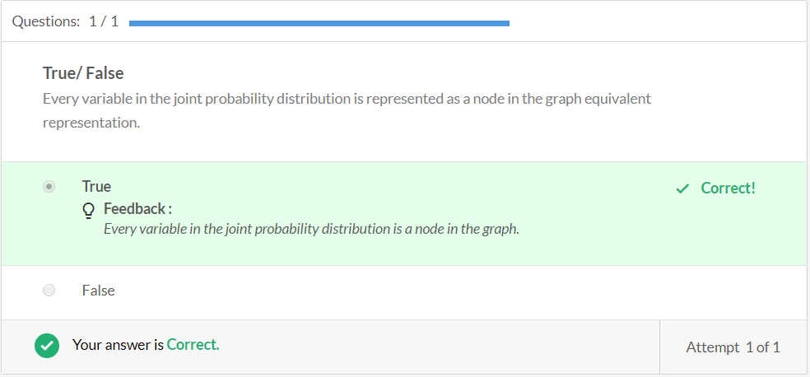 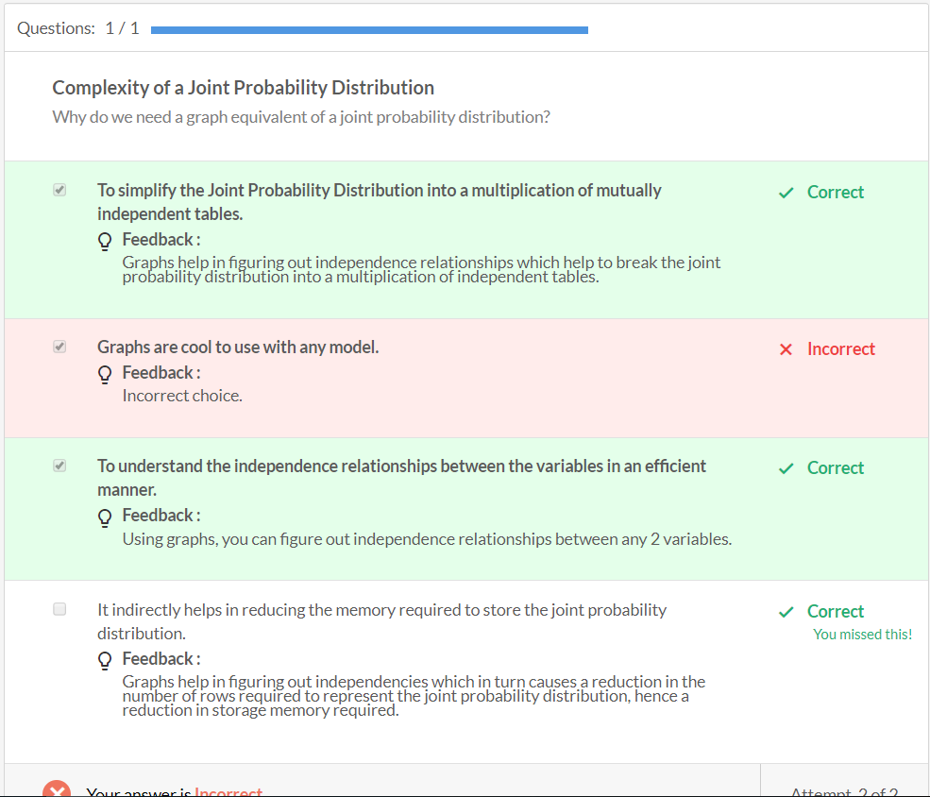

A joint probability distribution p(A, B, C, D, E) has the following independence relationships:

1. A ⊥ B : A is independent of B

2. D ⊥ {A, B, C, E}: D is independent of all A, B, C and E.

Given the graphs below, answer the question that follows:

1.

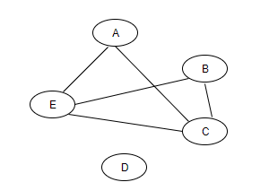

2.

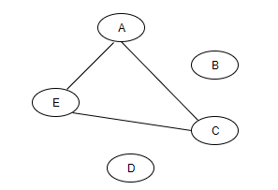

3.

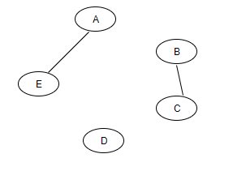

4.

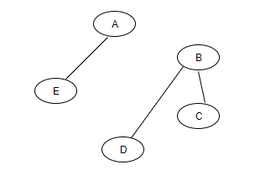

Questions:1/1

**Independence using graphs**

Which of the following graphs captures both the above independence relationships?

Top of Form



1



2

**Feedback :**

All the independencies are satisfied.

**Correct**



3

**Feedback :**

All the independencies are satisfied.

**Correct**



4

Bottom of Form

**done**Your answer is **Correct.**

Attempt 1 of 2

Questions:1/1

**Graph representation**

Consider a joint probability distribution p(A,B,C,D,E). Upon consulting with domain experts and observing the independencies in the joint probability distribution, we get the following graph:

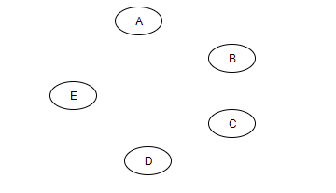

Top of Form



p(A).p(B).p(C).p(D).p(E)

**Feedback :**

*Since there are no edges connecting them, these are totally independent of each other. Hence, the joint probability distribution can be represented as*p(A).p(B).p(C).p(D).p(E).

**Correct!**



p(A).p(B,C).p(D,E)

Bottom of Form

**done**Your answer is **Correct.**

Attempt 1 of 1